Concordia University

Curatorial Essay
Priya Zoe Jain’s Pockets: Creating Space For Community and Commemoration

Gabrielle Montpetit
Student ID# 26980260
ARTH 389
Dr. Alice Ming Wai Jim
December 1, 2016
Priya Zoe Jain’s Pockets: Creating Space For Community and Commemoration
Priya Zoe Jain’s community oriented, process-based, and sustainable art practice, facilitates healing, knowledge-sharing, and dialogue within her communities, in Montreal, Canada. By adopting a textile-based art practice and employing a medium that has been relegated to the margins of the art world and labeled as “women’s work”, Jain’s Pockets (2016) is a project born of a community skill-sharing and material repurposing initiative centered on hand stitching and fabric dyeing (Fig. 1). The tactile nature and warm colors used in her work emphasize the nurturing qualities we associate with textile, and Jain’s practice as one that aims to engage in a process of healing. In Pockets, large textile panels of sewn pockets are filled with found objects containing specific memories from Montreal’s LGBTQIA2S and people of colour (PoC) communities, seedlings, and newspaper clippings (Fig. 2). Each of these inclusions speak to different issues such as marginalization within society and the art world, and commemoration – specifically the act of choosing to hold onto certain objects or memories and the reasons why. In Jain’s piece, the significance of these issues is suggested by the weight of objects contained by each pocket (Fig. 3). Inspired by social activists and scholars bell hooks and Audre Lorde, as well as Indigenous activist movements such as Idle No More, Priya Zoe Jain creates the space for racialized artists within the realm of conceptual art, which has long rejected the voices of artists that do not fit into the Eurocentric conception of art history.
In the context of Canada’s 150th anniversary, Montreal’s 375th anniversary, and the 389th anniversary since the first recorded arrival of a Black slave in Canada, Jain’s Pockets creates space for those who have been marginalized within these overarching historical narratives. A space to enter into dialogue about memories individuals might carry from the place they inhabit, and the emotional labor that PoC (and other marginalized peoples) continuously pour into their communities and in the reclamation of their histories. The process-based, and skill-sharing nature of Jain’s work is inspired by a long line of feminist works, which engage in these community projects that reclaim “women’s work” and use it as a tool for activism and healing.
Socially conscious, textile-based art practices have been associated with feminism since the 1970’s. The medium’s ability to subvert not only hierarchies of gender, but also hierarchies of race, is often overlooked within the Western art world. This is partly due to the fact that craft has not only been dismissed based on its association to women’s work, but also its association to women of colour (WoC), both of which do not fit into the restrictive structures of the art historical canon. An example of this are Faith Ringgold’s (b. 1930) quilts inspired by her African heritage, recounting the stories and traumas of her community in the 1980’s (Fig. 4). Ringgold was one of the “feminist artists at the time to initiate a critique of the hierarchy of art and craft by elevating the denigrated practices and materials of women’s traditional fiber-craft to the level of high art” in her own work.
Jain’s use and elevation of a marginalized medium into a gallery setting therefore questions the marginalization of PoC both within the conceptual art world and society, and reclaims a history of WoC who have used this medium to contest both racism and sexism. By reclaiming traditional craft techniques such as sewing and hand-dyeing fabric, Jain’s work offers an alternate model of artistic identity within the rigid confines of Western art history, and accommodates her oppositions to the racist and sexist values that still shape the mainstream, white, and male-dominated art world today.
In addition, Jain’s inclusion of textual components in her work (such as the media clippings of the Idle No More and anti-pipeline movements inserted into the hand-sewn pockets), emphasize her antiracist and feminist position, as well as her commitment to narratives of resistance. In a time where media still demonizes PoC, and the United-States elects a president whose rhetoric centers around fear and racism, the integration of media clippings treating issues of environmental and systemic racism in Jain’s work leaves us to wonder what is chosen to remain in the collective consciousness and what is immediately cast aside. This may raise certain questions, such as: This upcoming year, in the context of Canada’s 150th anniversary, will the ongoing oppression and history of violence against Indigenous people and PoC in Canada be addressed? Probably not. Pockets creates space to commemorate the women, PoC, Indigenous people, LGBTQIA2S, and other marginalized people whose struggles in society often go unaddressed. This commemorative aspect of Jain’s work is mediated through the non-traditional/Western nature of her creation as well as the references to her community.
Through its collaborative and interactive nature, Jain’s installation is always in dialogue with the community it aims to address. Throughout the creation process, Jain has called on the PoC and LGBTQIA2S community in Montreal to come share their sewing skills, their knowledge of the craft, as well as leave behind anything (an object, a story, etc) that could eventually become part of the installation. In the gallery, Pockets has physically transformed the spaces where it has been shown, concealing part of their architectural structure. Visitors are encouraged to interact with Jain’s installation, look inside the pockets, take something that interests them, or leave something they would like to contribute to the piece. In this context, craft’s communal quality and transformation of public spaces provides a rich context for rethinking contemporary activism. As Thompson explains, the social nature of Jain’s work demonstrate how these art practices point to a new social order – new ways of life that emphasize participation, and challenge power. In the art world, just as in society, there are strict rules that govern what you can and cannot do (indicated by the signs that usually read “do not touch!” or “no pictures”). Jain’s work counters these “rules” governing how we navigate social space, and is symbolic as a powerful tool for change. In its anti-representational and participatory qualities, the work acts directly in the political sphere, and takes shape as a form of educational tool (through skill and knowledge sharing) that challenges structures of power, culture, and politics.
However, the subversive nature of Jain’s educational stance is not to try to educate the community at large. As Audre Lorde has famously written: “Traditionally, […] it is the members of oppressed, objectified groups who are expected to stretch out and bridge the gap between the actualities of our lives and the consciousness of our oppressor. […] In other words, it is the responsibility of the oppressed to teach the oppressors their mistakes.” Constantly educating the groups that oppress you (i.e. PoC educating white people about racism, women educating men about sexism), is a drain of energy, and allows the oppressors to elude any sense of accountability for their actions. As Lorde explains, this energy “might be better used in redefining ourselves and devising realistic scenarios for altering the present and constructing the future.” Jain’s efforts to encourage skill and knowledge sharing within her community refocus these energies within it, in order to create a discursive space where political and social change can take place. This also builds what bell hooks has called “community of care”, where relationships can be formed, safe from suspicion and blame – where people can turn towards each other to create a supportive community based on appreciation and gratitude in order to guide and shape new ways of being.
In the Montreal context, Jain’s work and its emphasis on sharing personal memories tied to the city may shed light on how fragmented identities are formed, especially concerning minority issues in Québec. In Québec, issues of race and cultural belonging are paired with issues of language, and are reflected in Québec politics, which constantly negotiates the values of multiculturalism versus assimilationism, and interculturalism versus republicanism – how to protect the majority’s culture while being inclusive to others. Within the larger Montreal community, Jain’s work raises awareness about oppression and marginalization by allowing a space to negotiate and communicate one’s identity to those who are often subject to racist or discriminatory policies. However, the installation also works in uniting people in recognizing that we all feel a certain appartenance or connection to the space we share, and hold specific memories tied to it. Jain’s work demonstrates how memories and commemoration can also act as bridges, connecting both marginalized and mainstream communities. Jain encourages her viewers to think about how we occupy space together, through the inclusion of objects that recall distinctly Montreal moments (e.g. foliage from the many alleys found in the Plateau Mont-Royal).
In conclusion, the potentiality of craft towards community building and social activism is revealed in Jain’s Pockets, through a textile-based initiative that promotes skill and knowledge sharing and exchange. The pockets, and what is contained inside them, can symbolize for some the weight of the emotional labor they pour into their communities and social activism, in order to create safe spaces for marginalized people and change the oppressive structures that still govern society. The pockets also symbolize the weight of certain traumatic memories, but bring hopes for healing in a socially conscious environment. The memories that are tied to Canada and Québec, their colonial pasts and racist policies, are often traumatic for those who have been oppressed by these histories. They also raise questions like: When will they be given the space to address these issues and start healing? Socially engaged works like Jain’s, which operate in a community-building and space-making framework, act as powerful political tools that facilitate healing in communities that carry the traumas of systemic oppression at the hands of a white-supremacist system.
Bibliography
Auther, Elissa. “The Feminist Politicization of the Art/Craft Divide.” In String Felt Thread: The Hierarchy of Art and Craft in American Art, 93-162. Minneapolis; London: University of Minnesota Press, 2010.

Bouchard, Gérard. L’Interculturalisme: Un point de vue québécois. Montréal: Les Éditions du Boréal, 2014.

Bratich, Jack Z., and Heidi M. Brush. “Fabricating Activism: Craft-Work, Popular Culture, Gender.” Utopian Studies 22, no. 2 (2010):233-260. URL: http://www.jstor.org/stable/10.5325/utopianstudies.22.2.0233.

hooks, bell. Belonging: A Culture of Place. New York: Routledge, 2009.

Lorde, Audre. “Age, Race, Class, and Sex: Women Redefining Difference.” In Essays & Speeches by Audre Lorde, 114-123. Berkeley: Crossing Press, 2007.

Robertson, Jean. "Feminism and Fiber: A History of Art Criticism." Surface Design Journal 26, no. 1 (Fall 2001): 39-46. Art Full Text (H.W. Wilson), EBSCOhost (accessed October 23, 2016). URL: http://0-search.ebscohost.com.mercury.concordia.ca/login.aspx?direct=true&db=aft&AN=504978822&site=eds-live.

Thompson, Nato. “Living as Form.” In Living as Form: Socially Engaged Art From 1991-2011, edited by Nato Thompson, 16-33. New York: Creative Time; Cambridge: MIT Press, 2012.

Primary Sources

Jain, Priya Zoe. Email Google Docs version of Curriculum Vitae, October 17, 2016.

Place to B Canada. “Place to B – World Social Forum.” Accessed October 22, 2016. URL: http://www.placetob.org/evenement/place-to-b-world-social-forum/.

Priya Zoe Jain. Accessed November 18, 2016. http://www.priyazoejain.com/.

Sustainability Action Fund. “Sustainability Yearbook 2015-2016.” Accessed October 22, 2016. URL: http://www.safconcordia.ca/sustainability-yearbook-2015-2016/.

World Social Forum. “Programming.” Accessed October 22, 2016. URL: http://www.placetob.org/evenement/place-to-b-world-social-forum/.
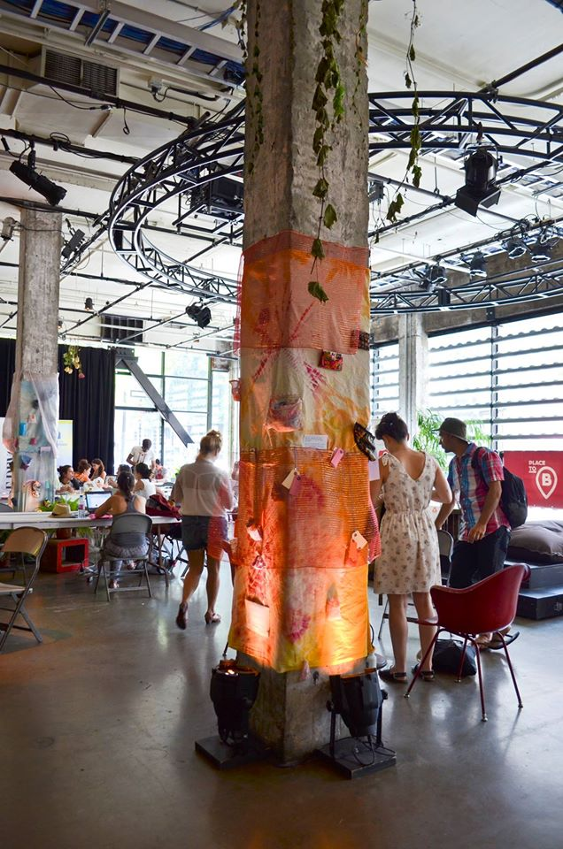
Figure 1. Priya Zoe Jain, Pockets, 2016. Found materials/objects, fabric/textile, and foliage. Interactive installation at Société des Arts Technologiques, Montréal, World Social Forum, August 9-14, 2016. Photo courtesy of the artist.
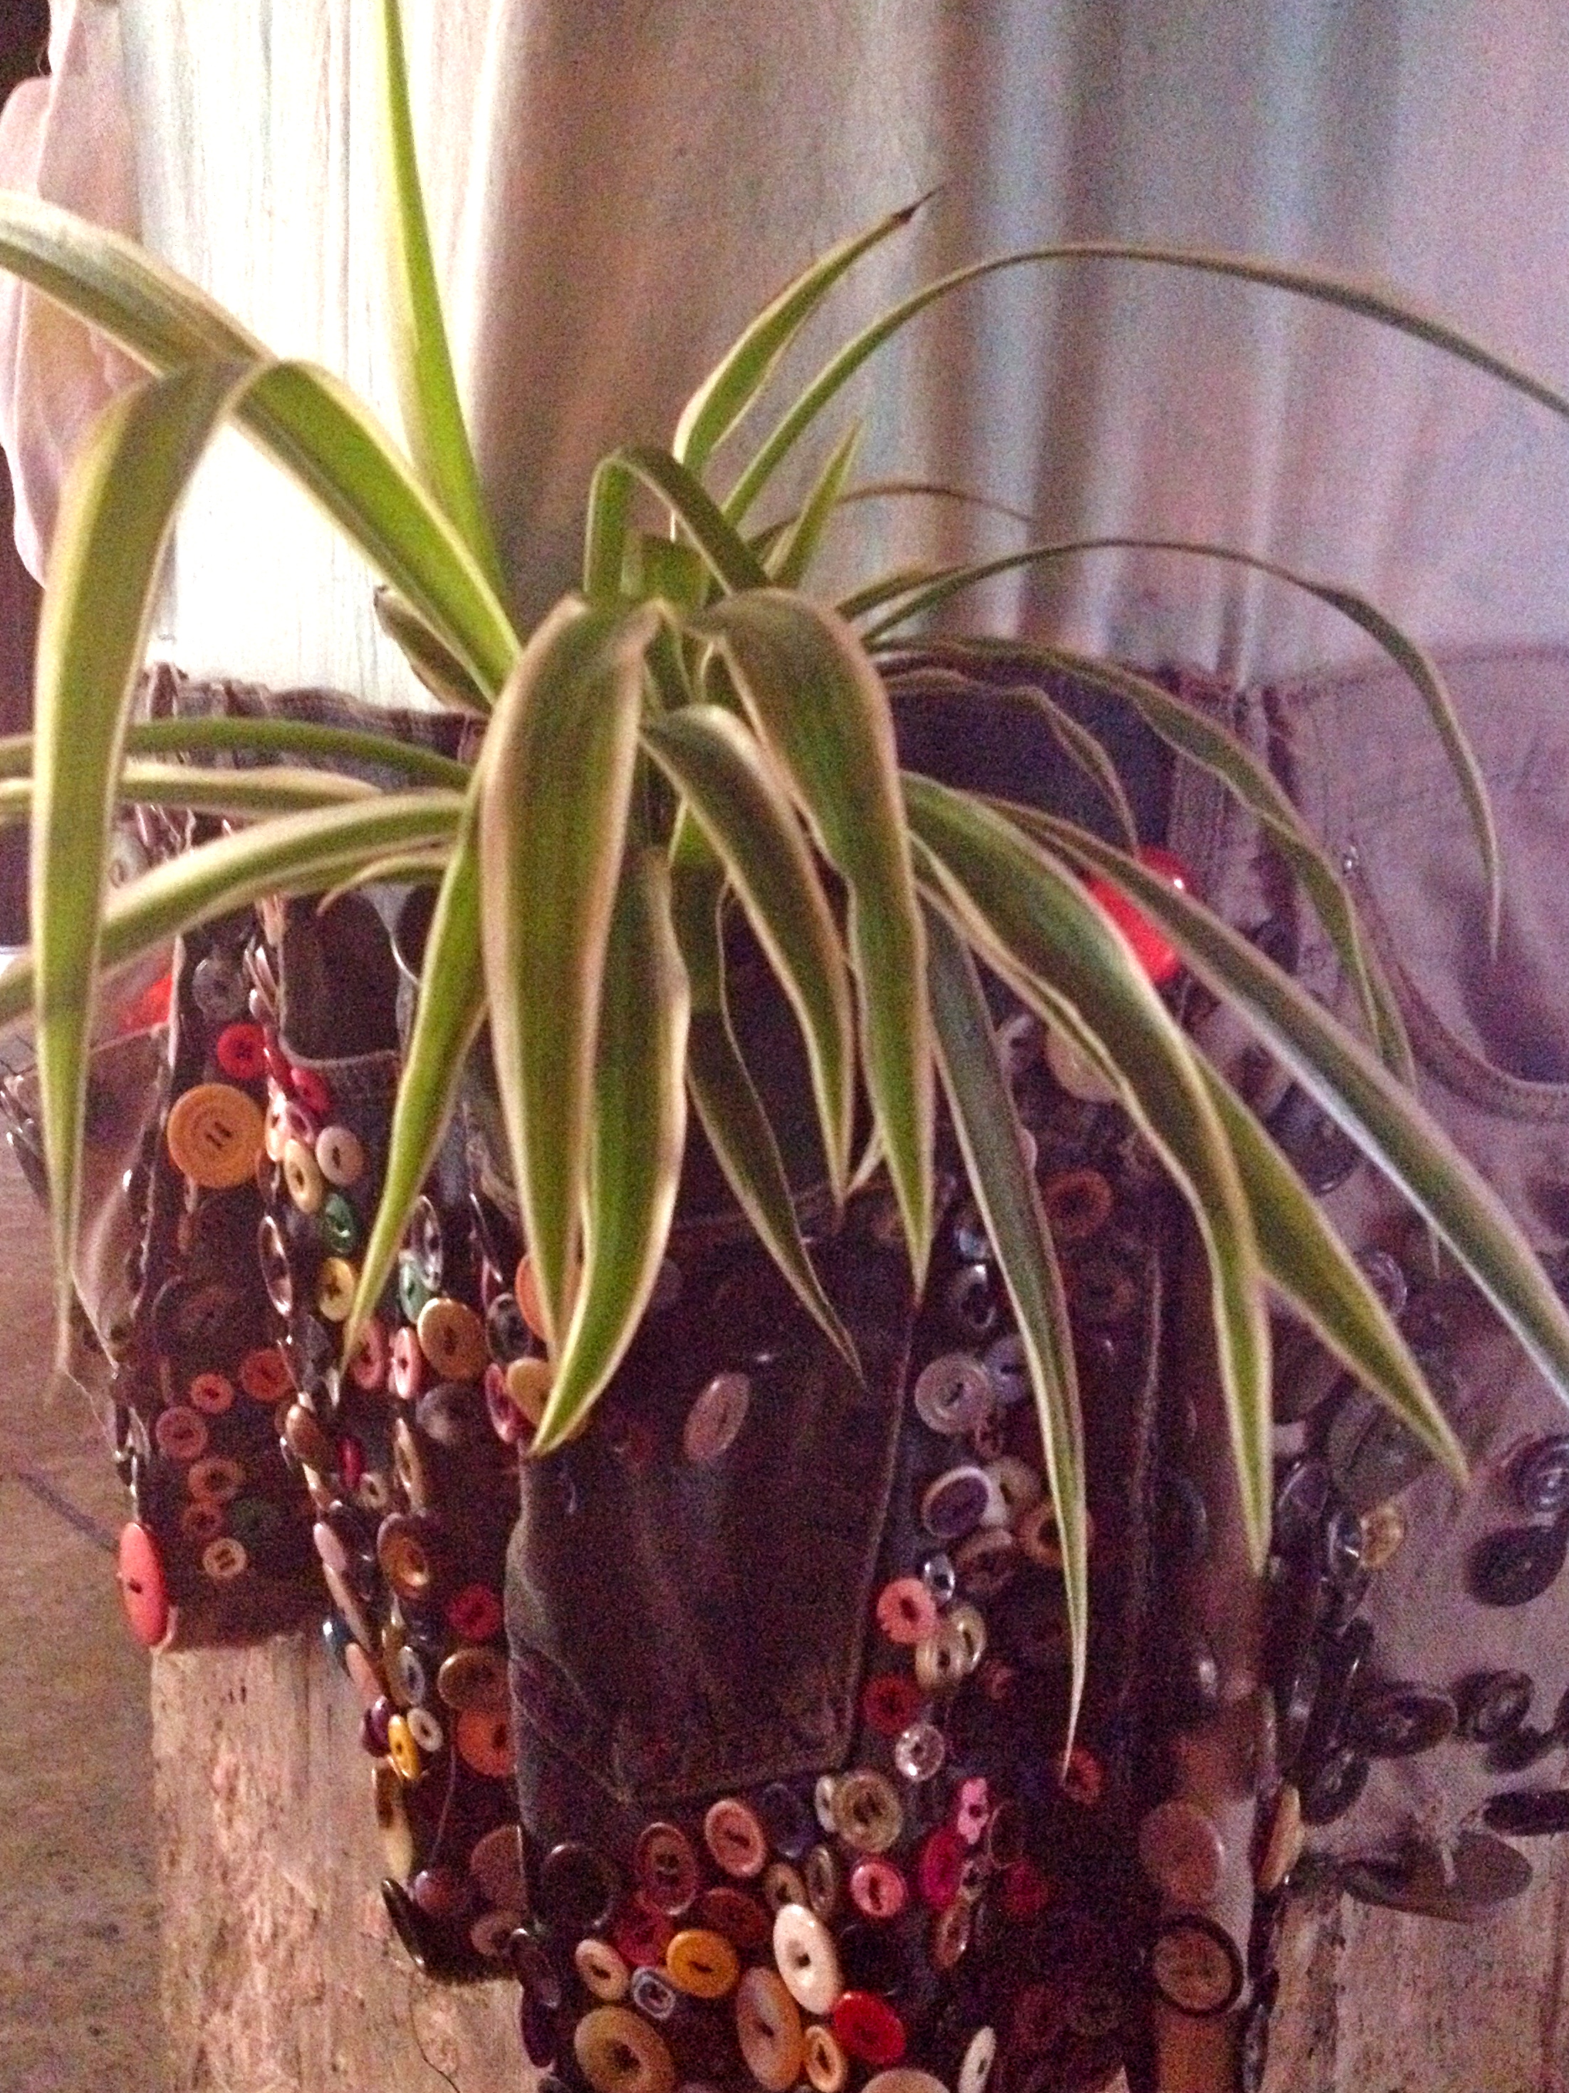
Figure 2. Priya Zoe Jain, Pockets (detail), 2016. Found materials/objects, fabric/textile, and foliage. Interactive installation at Société des Arts Technologiques, Montréal, World Social Forum, August 9-14, 2016. Photo courtesy of the artist.
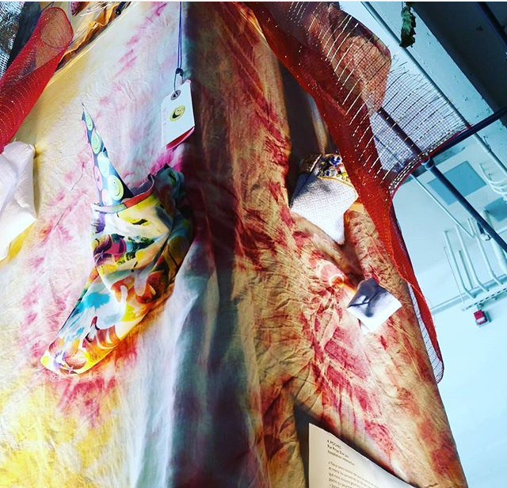
Figure 3. Priya Zoe Jain, Pockets (detail), 2016. Found materials/objects, fabric/textile, and foliage. Interactive installation at Société des Arts Technologiques, Montréal, World Social Forum, August 9-14, 2016. Photo courtesy of the artist.
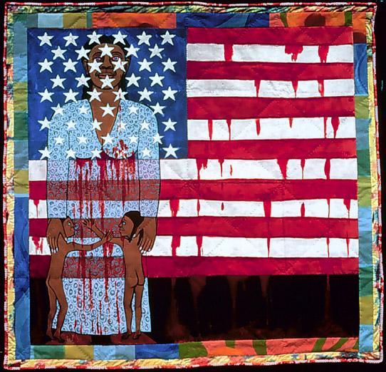
Figure 4. Faith Ringgold, The Flag is Bleeding #2, 1997. Quilted fabric, and paint.

This is one of the accepted acronyms for this community, and stands for: “Lesbian, Gay, Bisexual, Transsexual, Queer, Intersexual, Asexual, and Two-Spirit peoples”.
Idle No More. “The Vision.” Accessed November 24, 2016. http://www.idlenomore.ca/vision. Idle No More is a movement that fights for Indigenous sovereignty and the protection of land and water in Canada.
There are multiple feminisms, which have developed in different places, at different times in history. For the purpose of this essay, feminism will be restricted to the notions of Western feminism.
Elissa Auther, “The Feminist Politicization of the Art/Craft Divide,” in String Felt Thread: The Hierarchy of Art and Craft in American Art (Minneapolis; London: University of Minnesota Press, 2010), 98.
For example, Ringgold’s “Flag Story Quilt” series (1980s-1990s) speaks to the marginalization and oppression of the Black community in the United-States, by questioning the idea of the American ideal.
Ibid., 97.
Ibid., 99.
Jack Z. Bratich, and Heidi M. Brush, “Fabricating Activism: Craft-Work, Popular Culture, Gender,” Utopian Studies 22, no. 2 (2010): 234. URL: http://www.jstor.org/stable/10.5325/utopianstudies.22.2.0233.
Nato Thompson, “Living as Form,” in Living as Form: Socially Engaged Art From 1991-2011, ed. Nato Thompson (New York: Creative Time; Cambridge: MIT Press, 2012), 19.
Ibid., 19-22.
Audre Lorde, “Age, Race, Class, and Sex: Women Redefining Difference,” in Essays & Speeches by Audre Lorde (Berkeley: Crossing Press, 2007), 114.
Ibid., 115.
Ibid.
bell hooks, Belonging: A Culture of Place (New York: Routledge, 2009), 228-230.
These are complex terms, and their definitions may vary according to the legal system. Multiculturalism as policy ensures that all citizens can keep their identities, can take pride in their ancestry and have a sense of belonging (the recognition and preservation of diversity). Assimilation as policy promotes the unification of culture, where a minority group (often forcefully) adopts the customs and language of the cultural majority. Interculturalism as policy is concerned with the relationship between the cultural majority and cultural minorities, and promotes integration through exchange and interaction. Republicanism is the ideology of being a citizen in a state as a republic under which the people hold popular sovereignty.
Gérard Bouchard, L’Interculturalisme: Un point de vue québécois (Montréal: Les Éditions du Boréal, 2014), 231.

